1. The efast signer will need to utilize their login on our website <https://plansponsorlink.com/tra401k/login> to access and ultimately sign the 5500.
2. Once logged in on our site, click on the "Sign My 5500" button located in the gray/black bar.

1. A "new" screen will pop up, and you will click on the blue box on the left-hand side labeled "E-Sign 5500”

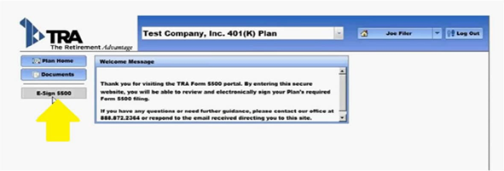

1. The next screen (below) outlines the steps necessary to complete the filing:
2. Print the form (you can print to pdf if you would like). **Note, you will not be able to enter your DOL signing credentials until after you "print" the Form 5500.
3. Review and Sign the Paper Form. Retain this for your records.
4. In the boxes provided, enter in the DOL User ID and DOL PIN provided by the DOL. **Note, the DOL User ID begins with the letter "A" followed by a series of seven number. The DOL PIN is a 4-digit number.

